**llcad** om« 444 Ly Thuong,Kc1S1. Wont 6. c Mau CH). Co Mourrovm\'l·, V1c1n:u11 ltrpoffltt: 2/\2Ngurcn1111Mmh Khoi. O31.oo Wrui.l, D1 ,n,101, 1lo Chi Minh. V1cu1am Tel (84)1Q()3557799 l.;mo,I <IIIOCl'ICl,(!\111orv1c1s..ifooJ com \ll

fa, (84)290 JS32021 Web '""" quo.::11cts..":lfooi.lcom ,n

**U@-C V IT Corp**

**FLOWCHART**

**PRODUCT: FROZEN PEELED VANNAMEI SHRIMPS**

**No Prorrssin1t**

Row material reception

1. Wru.hing I
2. Pre-Processing I

(Dchcading)

1. Wnshing 2
2. Sizing
3. Washing3

Pre-Processing 2

1. (Peeling)
2. Foreign matter checking
3. Washing4
4. Soaking
5. Washing *5*
6. Freezing

IJ Glazing

1. Re-Freezing
2. Weight - Putting in to bag
3. Metal Detecting
4. Packing

18 Col

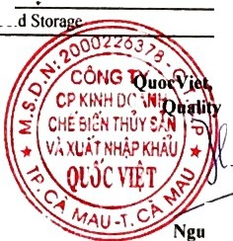

**05th** - **SEP, 2023**



/

**yen Hoa Mai**

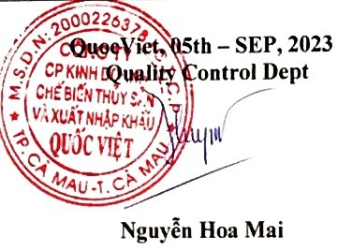**QU '-CVIETCorp**

**QUOC VIET SEAPRODUCTS PROCESSING TRADING** & **IMPORT** - **EXPORT CORPORATION -FACTORY** IT

Head Office: 444 Ly Thuong Kiet, Ward 6, Ca Mau City, Ca Mau Province, Viet Nam Tel (84)290 3557799 Fax (84)290 3832021

Representative Office: 2A2 Nguyen Thi Minh Khai, District I, Ho Chi Minh City, Viet Nam

Email: [shrimp@quocvietseafood.com.vn](mailto:shrimp@quocvietseafood.com.vn) Website:[www.quocvietseafood.com.vn](http://www.quocvietseafood.com.vn/)

**INGREDIENT LIST**

**PRODUCT: FROZEN PEELED VANNAMEI SHRIMPS**

|  |  |  |
| --- | --- | --- |
| **Ingredient name** | **PERCENTAGE** | |
| Shrimps | 99.0% | |
| Sodium Polyphosphate | 0.5% | |
| Salt | 0.5% | |
| **Total** |  | 100.0% |